**DAILY ONLINE ACTIVITIES SUMMARY**

|  |  |  |  |  |  |  |  |  |
| --- | --- | --- | --- | --- | --- | --- | --- | --- |
| **Date:** | **30/5/2020** | | | | | **Name:** | **Banish M G** | |
| **Sem & Sec** | **8th Sem** | | | | | **USN:** | **4AL16CS020** | |
| **Online Test Summary** | | | | | | | | |
| **Subject** | | **BDA** | | | | | | |
| **Max. Marks** | | **20** | | **Score** | | | **17** | |
| **Certification Course Summary** | | | | | | | | |
| **Course** | **Udemy: Python for Data science and Machine Learning** | | | | | | | |
| **Certificate Provider** | | | **Udemy** | | **Duration** | | | **4 hrs** |
| **Coding Challenges** | | | | | | | | |
| **Problem Statement:**  1.   Find the number that is missing from the array containing n distinct number taken from 0,1,2. . . .n | | | | | | | | |
| **Status:COMPLETED** | | | | | | | | |
| **Uploaded the report in Github** | | | | | **yes** | | | |
| **If yes Repository name** | | | | | B**anish_MG** | | | |
| **Uploaded the report in slack** | | | | | **yes** | | | |

Online Test Details: (Attach the snapshot and briefly write the report for the same)

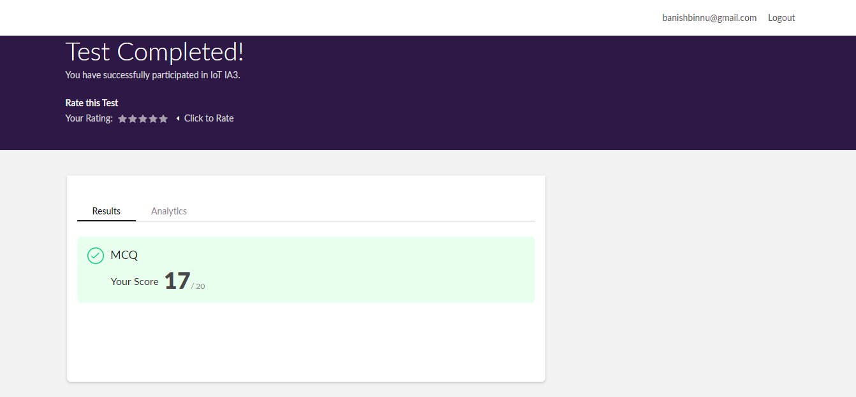

Certification Course Details: (Attach the snapshot and briefly write the report for the same)

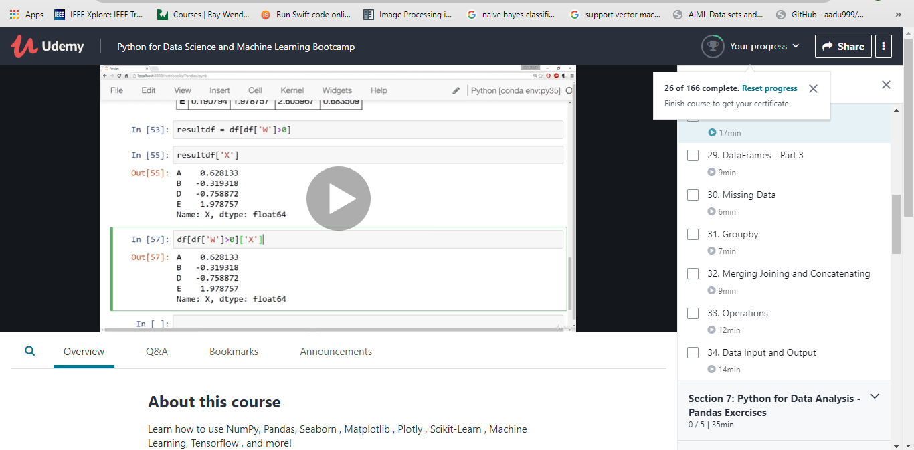

Coding Challenges Details: (Attach the snapshot and briefly write the report for the same)

Find the number that is missing from the array containing n distinct number taken from 0,1,2. . . .n

#include<stdio.h>

int getMissingNo(inta[],intn)

{

int i, total;

total=(n+1)*(n+2)/2;

for(i=0;i<n;i++)

total-=a[i];

return total;

}

intmain()

{

int a[]={1,2,4,5,6};

int miss=getMissingNo(a,5);

printf("%d",miss);

getchar();

}